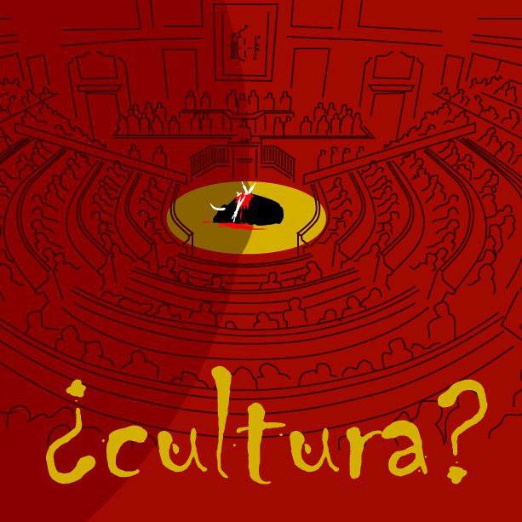
REQUIRED FOR EVERYONE:
To many residents of the United States, bullfighting looks cruel and inhumane; to many residents of Latin American and European countries, bullfighting is an artistic and noble part of their culture. How do you feel about bullfighting - is it an important cultural event or a display of animal cruelty? Thoroughly support your answer.

Bullfighting has been banned in some regions of the Spanish-speaking world, such as the Cataluña region of Spain. Bullfighting has returned to live television within the last 5 years. Children are now admitted to bullfights with an accompanying adult, also a more recent decision. Matadores, citizens, and bullfighting fans have very strong opinions about these decisions. How do you feel about this? Thoroughly respond to each of these points: banned bullfighting, bullfighting on live TV, and children at bullfights.
- Submit your response via GoogleDocs. Responses should have organized thoughts, proper grammar and spelling.

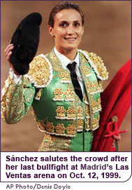

Cristina Sanchez the first woman bullfighter in modern times. In 1999 she announced her retirement at the end of the season, complaining that male prejudice against her was so strong she was unable to get the top billings she deserved. Some bullfighters have publicly declared that they would not fight on the same billing as her.

Write a reaction to this in which you address:
- Why do you think there’s much scrutiny over women in the bullfighting industry? Why are bullfighters refusing to fight with her? Will this situation inspire young women to become bullfighters or will it discourage them more? Do you agree or disagree with this? Are there other active women bullfighters? Support your answer.
- Can you think of examples of where women have been scrutinized in our culture for participating in a male-dominant sport or activity? Explain in detail.

- Submit via GoogleDocs. Reactions need to be well-written with organized thoughts, correct grammar and spelling.

El Arte
There are so many famous pieces of art with a bullfighting theme. They’re used as both decoration and souvenir.

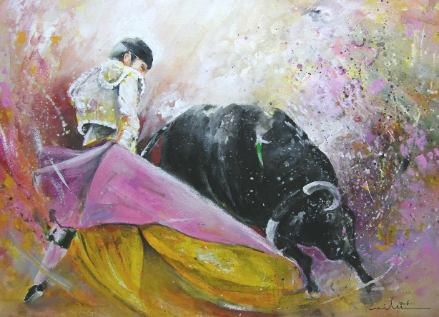
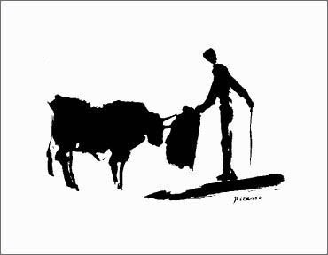

Take the provided bull outlines (or use your own) and turn them in to a creative work of art. Consider many different media—tissue paper, glitter, yarn, paint, pencil, collage, newspaper clippings, word art, etc.

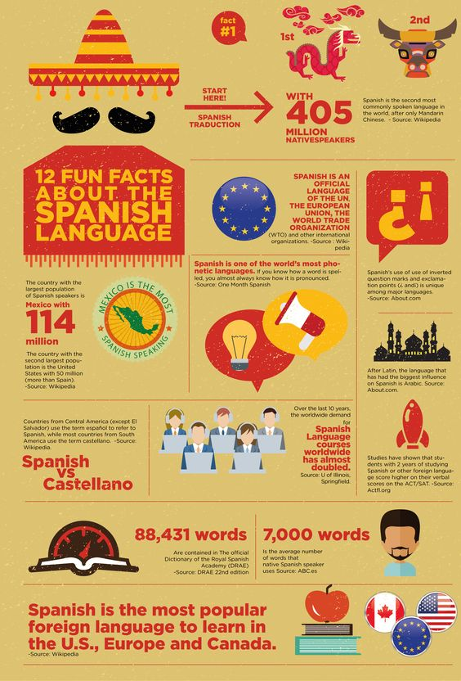

Do some basic research on “El Juli,” currently a very famous bullfighter in Spain. Find some fun and interesting facts about him and compile in to this poster-style graphic. Divide the poster in to sections, as seen here. Highlight single phrases, numbers or words and also include a sentence or two in each section. Use correct spelling and grammar. Include color and pictures. DO NOT PLAGIARIZE!
BIOGRAPHY REFERENCE BANK: http://search.ebscohost.com/login.aspx?direct=true&AuthType=cookie,ip,custuid&custid=infohio&db=brb&AN=202983865&site=ehost-live

